Stratford School for Aviation
OPEN HOUSE for December 2019 Enrollment
Saturday October 5, 2019 9:00 a.m. – 2:00 p.m.

The Stratford School for Aviation Maintenance Technicians is a Federal Aviation Administration (FAA) approved school that specializes in training Aviation Maintenance Technicians. The school offers a twenty-month program (2400 hours) of training in General, Airframe and Powerplant curriculums that prepare you to test to become a certified AMT.

Total Tuition is $7,200.

The Stratford School for Aviation Maintenance Technicians
200 Great Meadow Road
Stratford, CT 06615
203-381-9250
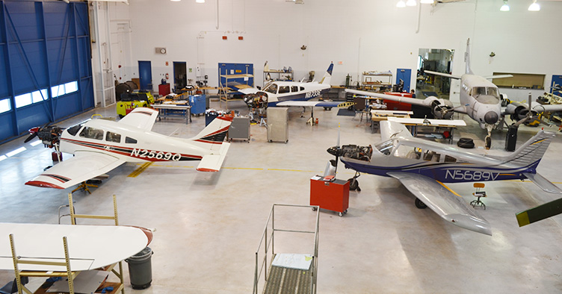
Directions:
I-95 Northbound: Take exit 30 (Lordship Blvd) and bear right at the bottom of the ramp. Continue on Lordship Blvd for 1 mile and turn right to continue on Lordship Blvd. The airport entrance will be on your left. Turn in and the school is the first building on the right, parking is located across from the building.
I-95 Southbound: Take exit 30 (Surf Ave). At the bottom of the ramp take a left on to Surf Ave. At the light turn left on to Lordship Blvd. Continue on Lordship Blvd for 1 mile and turn right to continue on Lordship Blvd. The airport entrance will be on your left. Turn in and the school is the first building on the right, parking is located across from the building.

The Stratford School for Aviation Maintenance Technicians is a post-secondary program administered by Bristol Technical Education Center, Bristol, CT and the Connecticut Technical Education & Career System, Hartford, CT.

